DESIGN

Overall architect
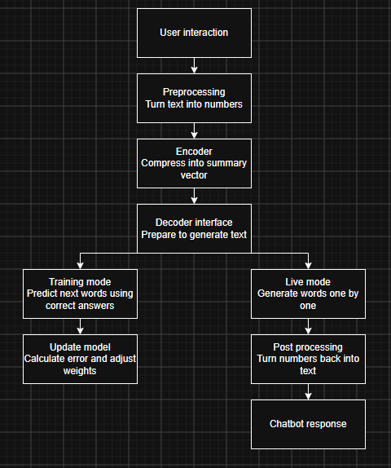
This shows the overall architectural design of the chat bot.
The aim of this is to pass a user’s input into a response or to train the model to know the correct answers using predictive text.
The users string must be processed into numbers through a tokenizer as it’s impossible to put characters into a vector diagram hence forcing a tokenizer to be made.
After the tokens have been generated the Encoder then places these numbers allocated to the tokens into a vector chart to be then read from later (this vector chart is an array of numbers displaying how closely related one token is to another)
After the decoder has logged and found all the Token ids it will then look at the neighbouring token ids to prepare to generate text
If the chatbot is in the training mode it will begin to guess the next token and looking at the correct answer to adjust the embeddings weights and bias, then repeating until accurate
If the model is in live mode the chatbot will see how accurate the guess may bee (how different the confidence between the highest words are) and will decide on that data to answer the question or phrase, if confidence is low requests the user to state the answer and then it goes into the training mode. If the chatbot is confident in its answer, it will post the numbers back through the tokenizer to turn it into text and print it to the user.

2. Tokenization
This program will use two tokenization’s one to encode the text and one to decode the token IDs back to text for the user

2.1 Encoder
The first tokenizer will be used to encode; this will use the sub word tokenization to divide words into smaller meaningful units to handle rare or compound words efficiently if . The encoder will use the Byte pair encoding (BPE) to form these sub words, how this works is shown in this diagram
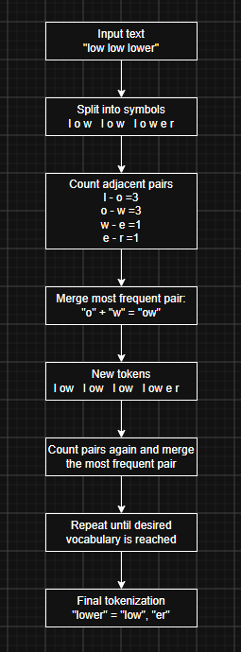

The idea behind BPE is to build words from frequently occurring pieces, these pieces will be decided within the programs leaning stage. The important benefit is that BPE can represent unknown or rare words by breaking them into smaller. Each of these pieces' “tokens” are then given a numerical value, this is the “tokenID” this will be done through random numbers filling an array with 2 dimensions and no id will be the same as another although one or more of their dimensions can be the same
BPE is used as it is the most efficient for the given task, Character tokenisation was thought however decided to not use this as it creates difficulty when coming to word boundaries and tasks like spelling correction, additionally it would be too slow for the machine to look up each individual character.

2.2 Decoder
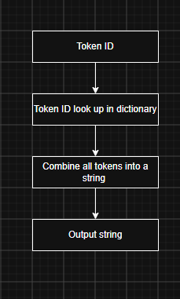
On the other hand the decoder is far simpler, this will come after the embedding when the chat bot requires to output a response visualised by the user, this means it will take the tokens it has chosen and put it through the decoder. The decoder looks up the given tokenIDs in the dictionary and coverts them back to text strings, this is then outputted.

3.

